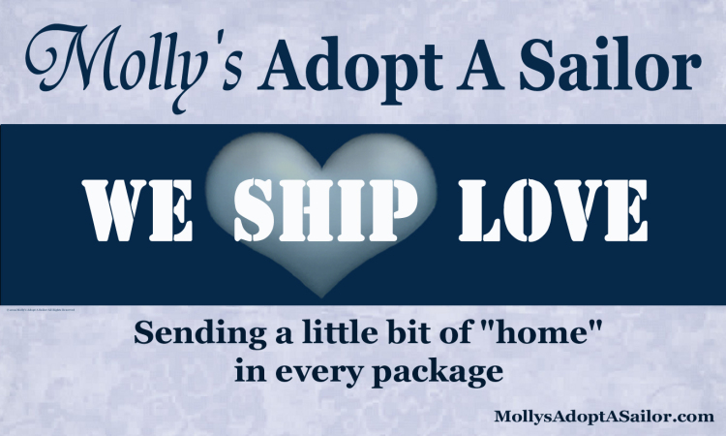

AMERICAN THE LAND OF THE FREE BECAUSE OF THE BRAVE
PACKING FOR 245 MALES 3 FEMALES
Molly’s Adopt A Sailor, a non-profit organization dedicated to ensuring our fighting men and women of all military branches deployed are not forgotten. We will be packing on Nov 2nd at the Port 5 in Bridgeport for and are asking for your support. Donated items will be needed no later then October 28. For further information, please contact Donna at 203-521-6935 or email me at donnabreunig@yahoo.com. Thank you for your support.
HOLIDAY ITEMS: CANDY CANES, TREATS, SMALL DECORATIONS!!!
DRINKS: GROUND COFFEE: MAXWELL HOUSE AND STARBUCKS (MOST REQUESTED BRANDS)
FLAVORED DRINK MIXES TO ADD TO WATER, HOT COCOA PACKETS, TEA, NO JUICE BOXES
FOOD: BEEF JERKY, CANNED ITEMS: TUNA, CHICKEN, SOUP, OATMEAL, DRIED FRUITS,
CEREAL BARS, PROTEIN BARS, ENERGY BARS, CRACKERS, DIPS, CHIPS, PRETZELS, EASY MAC & CHEESE,
MICROWAVE SINGLE MEALS, HAMBURGER HELP,
***Snacks are best in small individual sizes**
Health and Hygiene: PAIN RELIEVER, COUGH DROPS, LOTION, FOOT POWDER,
SHAVING CREAM, RAZORS, BODY WASH, SHAMPOO, CONDITIONER, DEODORANT,
TOOTH BRUSHES, TOOTH PASTE, LIP BALM ,
MISCELLANEOUS: CURRENT MAGAZINES, (ENTERTAINMENT, SPORTS, HEALTH,)
BOOK LIGHTS, HAND HELD GAMES, DOMINOES, YAHTZEE, CROSSWORD PUZZLES , STRESS BALL,
BLANK NOTE CARDS, PENS, PENCILS, , CARD GAMES, PUZZLES, DVD Movies (Non Violent),
Batteries (AAA) , Water Bottle, Coffee Cups with lids
www.Mollysadoptasailor .com Molly’s Adopt a Sailor is a 501C3 Organization

